KAVACH: A WOMEN SAFETY APPLICATION

## Rishab Mandal Arnav Malvia Ritik Mandal Pratish Makhija Kshitij Makhija



**THE HUMANITIES DEPARTMENT THADOMAL SHAHANI ENGINEERING COLLEGE**

## UNIVERSITY OF MUMBAI

**SEPTEMBER 2023**

KAVACH: A WOMEN SAFETY APPLICATION

## FOR

**THE HUMANITIES DEPARTMENT**

## BY

**Rishab Mandal Arnav Malvia Ritik Mandal Pratish Makhija**

## Kshitij Makhija

**THADOMAL SHAHANI ENGINEERING COLLEGE BANDRA, MUMBAI – 400050 UNIVERSITY OF MUMBAI**

# SIGN PAGE

Project Entitled – **KAVACH: A WOMEN SAFETY APPLICATION**

Submitted by – **Rishab Mandal**

## Arnav Malvia Ritik Mandal Kshitij Makhija Pratish Makhija

In the partial fulfilment of the degree of TE for PCE Project, Humanities Department, in Computer Engineering is approved.

Guide Examiner

In-charge Principal

Date:

# LETTER OF TRANSMITTAL

September 27, 2023

Dr. Rita Sharma

Head of Humanities Department

Thadomal Shahani Engineering College

W. P. G. Kher Marg, Off Linking Rd TPS III, Bandra (West)

Mumbai- 400050

#### Sub: Report on Kavach, a women safety application.

Dear Madam

This is to inform you that we, students of COMPUTERS Department, are submitting this report on Kavach as a part of the Professional Communication and Ethics syllabus. The report focuses on an innovative and impactful mobile application named "Kavach," specifically designed for women's safety and empowerment.

Kavach is a mobile application that has been meticulously developed to address the pressing issue of women's safety in today's society. The primary goal of Kavach is to provide women with a comprehensive and reliable tool that enhances their safety and well-being. In a world where personal security is of paramount concern, Kavach seeks to empower women with a versatile solution that fits right in the palm of their hands.

The objective of writing this report is to introduce our product in the market, explain the technology to the users. The report has covered every aspect of the technology behind it. The prerequisites, hardware and software required for the product have been introduced in the report. It also gives a brief description of the assembly of the product. The report discusses the limitations of the product in terms of cost factor and heat dissipation. It examines the problems encountered in the course of making of the product and various strategies implemented to tackle them. Also, the report will provide an in-depth introduction to the Kavach application, outlining its purpose, features, and the critical societal need it aims to address. The report will explore the design principles that prioritize ease of use and accessibility, especially in high-stress situations. One of the critical objectives of this report is to underscore the potential impact of Kavach. It will delve into how the application can contribute to a safer environment for women, both in terms of immediate safety and long-term empowerment. It will shed light on the inspiration behind the app's development and its potential impact. The content provided in the report has been taken from books, articles, journals, papers and information from the internet. We also collected first-hand information through the medium of surveys to get feedback from the users and to estimate the market and the potential audience.

The report provides implementation of this technology on wider scale and aims not only to introduce the Kavach application but also to advocate for its importance in addressing a crucial societal issue. Kavach represents a significant step towards ensuring the safety and

empowerment of women, and this report serves as a comprehensive resource to understand its objectives, design, and potential impact.

Sincerely yours,

Rishab Mandal

# TABLE OF CONTENTS

**Cover i**

Title Page ii

Sign Page iii

Letter of Transmittal iv

Table of Contents vi

List of Illustrations viii

Summary ix

Introduction xii

1. Introduction to Kavach 1
   1. Historical Background 2
   2. Need for Kavach 2
2. Requirements 4
   1. Software 4
   2. Hardware 7
3. Construction of Kavach 8
   1. Construction of application 8
   2. Planning of the layout 10
   3. Building the User Interface 11
4. Working 12
   1. App features and functionalities 12
   2. Emergency Response Mechanism 15
   3. Data security and privacy 15
5. Implementation 17
6. Advantages and Limitations 20
   1. Advantages 20
   2. Limitations 22
7. Conclusion 26

List of References 27

Bibliography 29

Glossary 30

# LIST OF ILLUSTRATIONS

**List of Images**

|  |  |  |
| --- | --- | --- |
| Image 4.1 | The Emergency Button | 25 |
| Image 4.2 | Location Tracking | 27 |
| Image 4.3 | One handed operation | 29 |
| Image 4.4 | Smart Watch | 29 |
| Image 5.1 | Features |  |
| Image 6.1 | Safe Zones |  |
| Image 6.2 | Smart Watch |  |

# SUMMARY

Women's safety apps have emerged as vital tools in addressing the pressing need to enhance women's security and empowerment. In today's technology-driven world, these apps enable rapid emergency assistance through distress signals to predefined contacts or emergency services, providing a lifeline in critical situations. Additionally, they offer real-time location sharing with trusted contacts, ensuring that friends and family can monitor users' whereabouts, enhancing overall safety. Moreover, they provide valuable safety tips, self-defence resources, and information on legal rights and support services, empowering women with knowledge and confidence.

### Introduction to Kavach

We delve into the historical background of the Kavach application, tracing its development and evolution. We discuss the societal context that led to the creation of Kavach and the pressing need for a dedicated women's safety application in today's world. This section provides a foundation for understanding the app's purpose and significance.

### Requirements

Kavach is designed with a comprehensive set of software and hardware requirements to ensure the safety and well-being of its users. On the software front, it supports both Android and iOS platforms, offering flexibility to a wide range of users. It prioritizes security with robust user authentication, including two-factor authentication and password recovery options. The emergency features, including a panic button with GPS tracking and SMS/email alerts, are seamlessly integrated with efficient contact management. Real-time location services, geofencing, and continuous tracking provide precise and timely information to designated contacts during distress situations. The app also allows users to manage their personal and medical information, with data backup and restoration capabilities, all while maintaining stringent privacy and security standards, including data encryption and user-controlled privacy settings. Regular updates and push notifications keep users informed and safe. Hardware-wise, the app is designed for compatibility with a wide array of Android smartphones and iPhones, utilizing the built-in GPS hardware and relying on active cellular or Wi-Fi connections for real-time communication. Overall, the Women Safety App ensures a user-friendly experience with an intuitive UI/UX design, emphasizing safety and trust through its visual elements and imagery while offering access to emergency services, community support, safety escorts, and medical assistance to enhance user security.

### Construction

The Kavach application was built using React Native, an open-source framework, and complemented with NativeWind CSS for streamlined UI development. The development environment was set up with Node.js and React Native's command-line interface for both Android and iOS. React Native's component-based architecture allowed for the creation of

native-like user interfaces using JSX. NativeWind CSS simplified styling with utility-first classes for responsive designs.

Navigation was managed using React Navigation, defining screens for various app sections. Redux handled state management, ensuring data consistency across user preferences and emergency contacts. External services and APIs, such as geolocation and SMS, were integrated for enhanced functionality. Rigorous testing, including unit and user testing, ensured a seamless user experience.

Cross-platform compatibility was achieved through React Native's capabilities, accommodating Android and iOS requirements. The app was deployed to app stores, and continuous updates improved performance, security, and user experience based on feedback and analytics.

### Working

Kavach is designed to empower and enhance personal security for users in various situations, such as walking alone at night or attending social events. It features an easily accessible Emergency Alert Button, which triggers notifications to preset contacts and authorities, along with real-time location tracking for quick response during emergencies. The app allows discreet audio and video recording for evidential purposes and can be operated with one hand for quick access to emergency features. In situations where the user cannot access their device, a safety word can be shouted to trigger emergency protocols.

The app also provides notifications and alerts about local safety concerns and recent incidents. A unique feature is the false shutdown, which activates in case of device theft, making it appear off while secretly recording audio and video. Moreover, the app seamlessly integrates with smartwatches to detect unusual heart rate and movement patterns, triggering an emergency when danger is sensed.

The Emergency Response Mechanism ensures swift assistance from designated contacts and authorities when an emergency alert is activated. Data security and privacy are paramount, with considerations including data minimization, end-to-end encryption, user consent, anonymization, user control, and secure authentication. Regular security audits, data breach response plans, and compliance with relevant regulations are also emphasized. Users are educated on safe app usage, and a comprehensive privacy policy is in place, emphasizing ethical considerations in user data handling to prioritize user safety and well-being.

### Survey

In order to get a better idea of the market and collect first-hand information, our group conducted a survey. We prepared a set of 9 questions to satisfy the purpose and identify the potential consumers for our product. We managed to gather sufficient data to analyse and convey our product to target audience.

1. What is your age ?*

Under 18

18-24

25-34

35-44

45-54

55 or over

1. Have you ever felt unsafe while walking alone?* Yes

No

1. Have you ever used a safety app before ?* Yes

No

1. What features would you like to have in a women's safety app? (Select all that apply)* Panic Button

Location Tracking

Emergency Contacts

Safety scores to locations on maps Marked Unsafe Areas

Self Defense Tips Community Safety Alerts Other:

1. Would you be comfortable with the app accessing your microphone 24*7 to trigger emergency using a safety word chosen by you ?*

Yes No

1. How would you prevent a prank/fake trigger on such safety apps? (Please specify):-*
2. Any other features you as an individual feel are needed? (Please specify):-
3. What would prefer ng in a panic situation?* SOS button on the App

Pressing power button thrice

Shouting out the safe word which is set by you

1. Would you like the option to review and modify the data that the app collects about you at any time ?

Yes No

We received over 75+ responses which gave a clear idea in what direction we have to work.

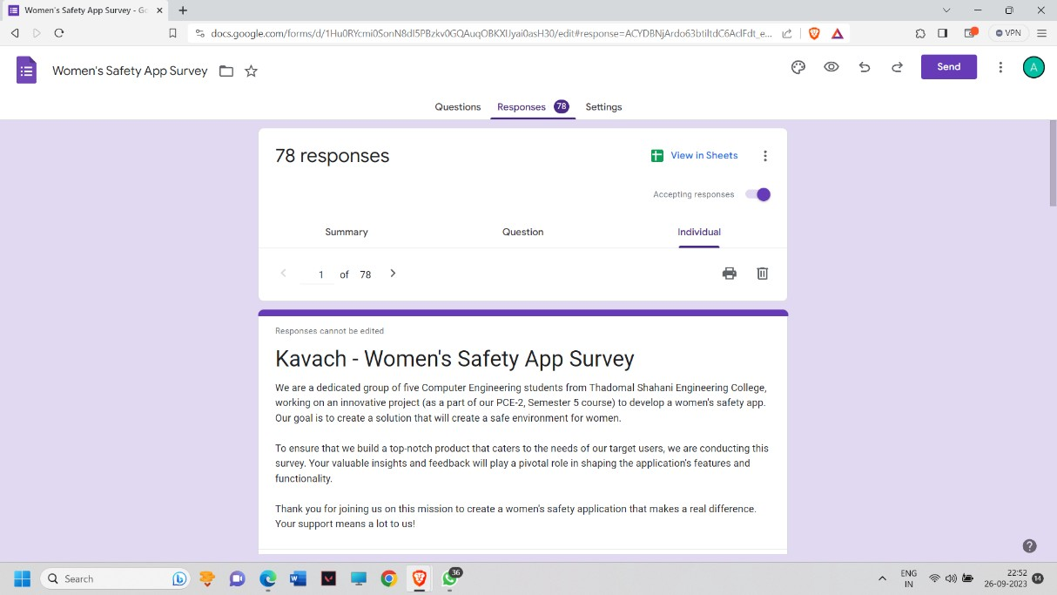

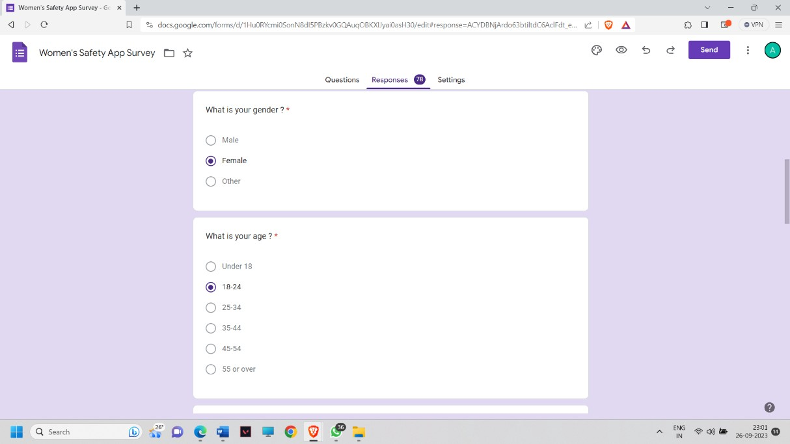

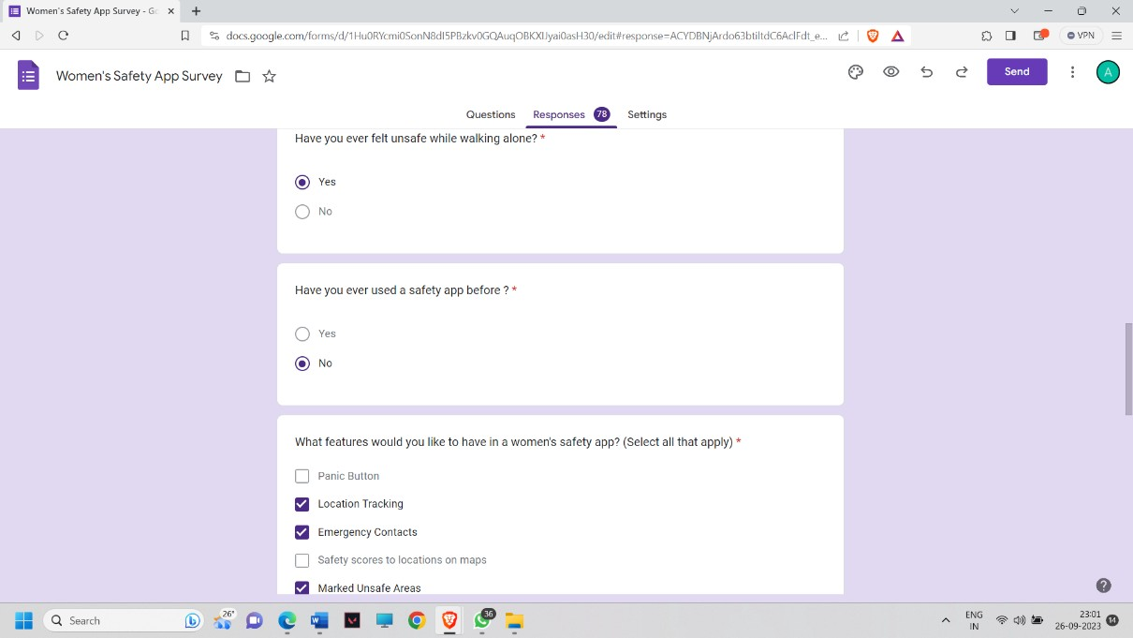

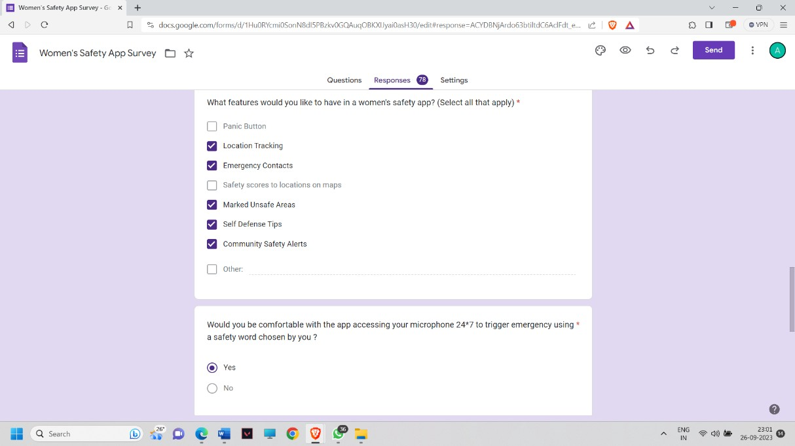

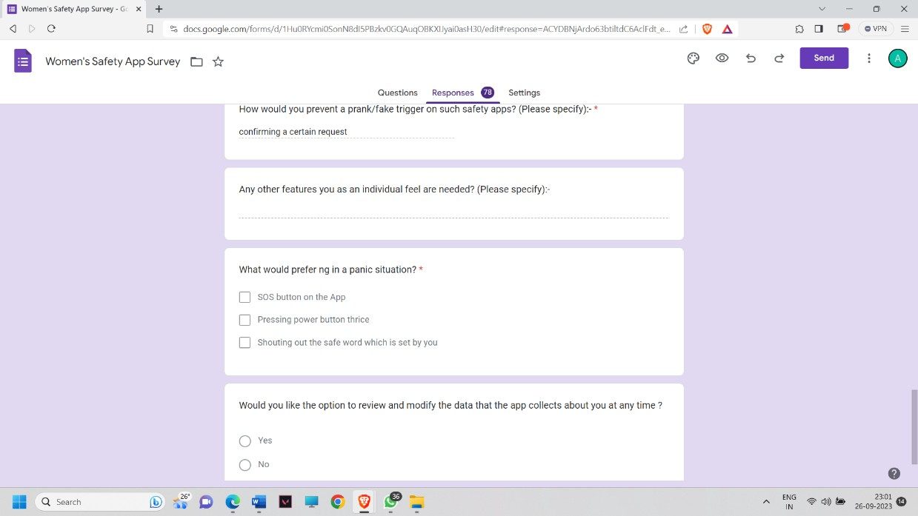

Images of the Google Form

### Advantages and Limitations

Women's safety apps bring several significant advantages to the forefront. Firstly, they provide a lifeline in emergencies through their rapid emergency assistance features, allowing users to send distress signals with their location to predefined contacts or emergency services, potentially saving lives. Secondly, real-time location sharing offers peace of mind by enabling users to share their whereabouts with trusted contacts, enhancing their overall safety, especially during late-night travel or in unfamiliar areas. Thirdly, these apps often include features like safe routes and navigation, helping women avoid potentially dangerous areas. Furthermore, they empower users with valuable safety tips, self-defence resources, and information on legal rights and support services, fostering knowledge and confidence. Privacy and security measures ensure users' personal information remains confidential, building trust. Women's safety apps also foster supportive communities, allowing users to share experiences and advice, and they contribute to raising awareness about women's safety issues, promoting a vigilant society. Lastly, the mere presence of such apps can act as a deterrent to potential attackers, knowing that their actions may be reported. Customization options, cross-platform accessibility, inclusivity, continuous improvement through user

feedback, and legal compliance further enhance their advantages, ultimately providing women with a sense of security and peace of mind. Despite their many advantages, women's safety apps also come with limitations. Firstly, they are heavily dependent on technology, relying on smartphones and network connectivity. This reliance makes them ineffective in areas with poor network coverage or when smartphones are unavailable or out of battery. Secondly, the potential for false alarms exists, as users may accidentally trigger emergency alerts, leading to unnecessary panic or diverting resources from genuine emergencies. Thirdly, the effectiveness of these apps depends on the availability and willingness of emergency services to respond quickly. In regions where emergency response may be slow or unreliable, the apps may have limited reach. Privacy concerns related to the collection and storage of personal data may deter some users.

### Conclusion

The conclusion encapsulates the report's findings and reiterates the significance of the Kavach application in enhancing women's safety. It serves as a conclusion and a call to action, emphasizing the importance of continued efforts in the realm of women's safety technology.

This report provides a comprehensive overview of the construction and functionality of the Kavach application. It underscores the critical role technology can play in addressing societal issues and improving the safety and well-being of women.

### INTRODUCTION

1. **INTRODUCTION TO KAVACH**

In the contemporary world, the issue of women's security has assumed critical importance. Women are subjected to harassment in various spheres of life, whether it be in educational institutions, workplaces, or even within the confines of their own homes. The pervasive fear of these incidents often restricts women from venturing beyond their perceived safe zones. With the escalating incidence of crimes against women, their freedom and sense of security are under constant threat. Critical situations can arise unpredictably and anywhere, necessitating the need for an application that empowers women to seek assistance or escape from perilous situations with utmost ease.

One of the primary challenges in addressing these incidents is the inherent limitations in the police response. Swift reaction to distress calls is not always feasible. This may be attributed to factors such as the inability to pinpoint the exact location of the crime or, in some cases, not being aware of the occurrence of a crime at all. Victims often find it difficult to reach out to the police with confidence and discretion. In response to these constraints, the Women's Safety Application is introduced as a smartphone app designed to offer a reliable means for women to seek police intervention in emergencies. It is crucial to recognize that victims of abuse frequently find themselves denied even the most fundamental human rights.

To cater to the immediate needs of women facing imminent danger, an application for women's safety has been devised, accessible with a single click. This application utilizes GPS to ascertain the user's precise location and dispatches a message containing the location URL to pre-registered contacts, thereby aiding individuals in precarious situations. A distinctive feature of the program is its periodic transmission of messages to registered contacts at

three-minute intervals, continuing until the user activates the "Stop" button. This continuous location monitoring via SMS facilitates the rapid and safe rescue of the victim.

The genesis of this application lies in the desire to create a secure environment through smartphones, given that these devices have become ubiquitous companions for people in today's world. Upon activation, the application immediately sends a message to the police, including the user's location details and contact information for a pre-selected list of emergency contacts.

This section introduces Kavach, an innovative solution to address the pressing issue of women's safety. It will delve further into the development, technical implementation, and features of the application, aiming to provide a comprehensive understanding of how Kavach empowers women to navigate a safer world.

#### Historical Background

ABHAYA: An Android App for Women's Safety

The development of the ABHAYA Android application marks a significant milestone in women's safety efforts, aimed at preventing incidents similar to the Abhaya case in Delhi. This innovative application harnesses 3G/2G data connections to continuously track the user's location in times of distress. It automatically dispatches location updates, accompanied by a URL link, to registered contacts at five-minute intervals until the user initiates the "stop" command.

Moreover, when the application is activated, a call is placed to the first registered contact, and location information is simultaneously sent to all registered contacts. This real-time location sharing feature ensures continuous tracking and heightened safety for women.

S-ZONE: A System for Women's Safety & Security

The paper titled "S-ZONE: A System for Women's Safety & Security" underscores the importance of identifying and escaping unsafe situations as the primary strategy to reduce the risk of violent crimes, including robbery, sexual assault, rape, and domestic violence. This system leverages cutting-edge mobile technology to empower women's safety.

S-ZONE operates as an Android-based platform designed to track users' locations through GPS, facilitating prompt emergency responses by rescue services in precarious situations. Contemporary women's safety solutions encompass a diverse range of options, including smartphone apps, security systems, and wearable devices tailored for everyday use. Some of these solutions incorporate intelligent features like notifying the police or designated contacts upon the user's activation of the power button. Subsequently, the system transmits the user's live location after one minute, ensuring an accurate tracking mechanism when the user relocates.

Additionally, certain systems integrate user authentication through fingerprint scanning, requiring periodic scans to maintain security. Failure to comply triggers an automatic transmission of the user's location to registered contacts via SMS. In critical circumstances, this system operates autonomously, providing an invaluable layer of protection for women without necessitating their direct intervention.

These historical developments in women's safety apps and systems signify significant strides in enhancing the security and well-being of women, offering versatile tools and methods to safeguard their lives and prevent potential dangers.

#### Need for Kavach

India, with its diverse culture, heritage, and traditions, has made significant strides in various spheres. However, when it comes to women's safety, it remains an issue that demands unwavering attention and concerted efforts. The country grapples with a range of safety challenges, encompassing not only urban centres but also remote rural regions. While women everywhere deserve to feel secure, the unique challenges faced by Indian women amplify the urgency of developing innovative solutions like Kavach.

Indian women encounter a myriad of safety concerns that are distinctive to the socio-cultural landscape of the nation. These concerns often manifest in the form of harassment, violence,

and discrimination, both in public and private spaces. The following are some of the salient issues that underscore the pressing need for an app like Kavach.

Street Harassment: Women in India frequently experience street harassment, ranging from catcalling and lewd comments to physical assault. The fear of such incidents can severely restrict their mobility and hinder their access to education and employment opportunities. Safety During Commute: Public transportation, such as buses and trains, can be unsafe for women, exposing them to the risk of harassment and assault during their daily commute. Ensuring their safety during these journeys is imperative for their participation in various facets of life.

Gender-Based Violence: India grapples with high rates of gender-based violence, including domestic abuse, dowry-related harassment, and honor killings. Protecting women from such violence is an essential aspect of ensuring their well-being.

Safety in Remote Areas: Rural areas often lack adequate infrastructure and security measures, leaving women vulnerable to various forms of exploitation and violence. Bridging this gap in safety is crucial for the empowerment of women in these regions.

Emergency Response: Rapid and effective emergency response is often lacking, leaving women in distress with limited options for immediate help. An efficient SOS functionality, as provided by Kavach, can be a lifeline in such situations.

Kavach, with its array of safety features and innovative technologies, emerges as a beacon of hope in addressing these pressing issues. Its design not only acknowledges the unique safety concerns faced by Indian women but also seeks to provide them with a robust tool to protect themselves in times of distress.

In the subsequent sections of this report, we will explore the features and functionalities of Kavach in greater detail, shedding light on how this innovative application can play a pivotal role in enhancing the safety and security of women in India. Through this examination, we aim to underscore the importance of Kavach as a vital step toward realizing the vision of a safer and more equitable India for all its citizens, regardless of gender.

### REQUIREMENTS

* 1. **Software Requirements:**

#### Platform and Development:

. Mobile App: Develop the application for both android and iOS platforms.

. Android Development use Java or Kotlin as the primary programming language.

. Ios development use swift or objective-c as the primary programming Language.

. Cross-platform Development considers cross platform frameworks like flutter, react native or Xamarin if want to streamline development for both android and iOS with shared

code-base.

. Development Environment: set up ideas such as android studios (for Android) and Xcode (for iOS).

#### User Authentication:

. User Registration and Login: implement secure user registration and login functionalities.

. Two-factor Authentication(2FA): Enhances security by integrating 2FA during login.

. Password Recovery: User should have the option to reset their password if forgotten.

. This process may involve sending a password reset link to the registered email address.

. User concept and privacy: Clearly communicate how user data will be handled and protected.

. Provide users with options to manage their data.

#### Emergency Alerts :

. Panic Button : Include a panic button that users can press in emergencies to send distress alerts to predefined contacts.

. GPS Tracing : Integrate gps functionalities to track the user’s location when the panic

button is activated.

. SMS/Email alerts : sends alert via sms or email to emergency contact with the users location details.

#### Contact Management :

. Add and manage Contacts : Allow Users to add and manage emergency contact within app.

. Contact sync : Provide options for syncing emergency contacts from users devices.

#### Location Services:

. Real-time location: Continuously update and share the user’s real-time location with their emergency contacts.

. Geofencing Tracking : Implement Geofencing to trigger alerts if the user enters or exits designated areas.

. Continuous Tracking : Implement continuous location tracking while the app is active.

. Ensure that the app can access the devices Gps and update the user’s location in real time.

#### User Profile :

. Personal Information: Allow users to update their personal information and profile picture.

. Medical Information: Provide an option for users to input any relevant medical info that emergency responders should know.

. Medical Profile : Fields may include blood type, allergies, medical conditions, meditation and emergency contact details.

. Backup user Profile Data : Regularly back up user profile data securely to prevent data loss

. Data Restoration : Allow users to restore their profile data if they switch to a new device or reinstall the app.

#### Privacy and Security :

. Data Encryption : Encrypt sensitive user data such was location and personal information.

. Privacy Settings : Enable users to control who can access their location information and contact details.

. Location Privacy : Provide users with options to share their location during emergencies ensuring their privacy when not in distress.

. Regular Updates : Keep the app up-to- date with the latest security patches and features to stay ahead of emerging threats.

#### Notifications :

. Push Notifications : implement push notifications to keep users informed about app updates safety tips and alerts.

#### Safety Resources :

. Emergency Services Integration : collaborate with local law enforcement agencies to enable direct emergency service requests within the app. Users should be able to quickly contact police, ambulance or other relevant services in case of an emergency.

. Community Support : Create a community feature within the app where users can connect with each other for support and share safety tips. This can include forums chat groups or even a panic button that alerts nearby users in distress.

. Safety Escorts : Integrate a Feature that allows users to request virtual or real-life safety escorts when they fuel unsafe, especially during nighttime or in unfamiliar areas.

. Medical Assistance : Include a feature that connects users with medical professionals or telemedicine services for immediate first aid in case of injuries.

#### Ui/Ux Design :

. Intuitive Interface : Design an easy-to-navigate user interface that is user-friendly and accessible.

. Visual Design : Color Scheme choose a colour palette that conveys safety and trust blues and greens often work well.

. Typography : Select clear and legible fonts for readability.

. Icons : Use universally recognizable icons for features like emergency contacts, location tracking and alerts.

. Imagery : Incorporate Imagery that resonates with the apps purpose, such as images of confident women or symbols of safety.

### Hardware Requirements

#### Mobile Devices:

. Android smartphone: Ensure compatibility with a wide range of Android devices.

. iPhone : Ensure compatibility with various iPhone models.

#### Gps and location services :

. Gps Hardware : Utilize the built in Gps hardware in smartphones for accurate location tracking with the app.

#### Connectivity :

. Cellular / Wi-Fi : Require active cellular or Wi-Fi connection for real-time alerts and location sharing.

### CONSTRUCTION OF KAVACH

The construction of the Kavach app was a meticulous process that prioritized the safety and well-being of women. The planning of the app layout was centred around creating an intuitive, user-friendly, and responsive interface using React Native and NativeWind CSS.

Our primary focus in the app layout design was to ensure ease of use during distress situations. The home screen prominently featured a panic button that could be easily accessed. Additionally, we incorporated geolocation services to provide real-time location tracking and sharing with trusted contacts. Users could customize their emergency contacts list and set up predefined messages for quick responses. The app also included educational resources and safety tips to empower users with knowledge.

### Construction of the application

In this section, we provide a detailed overview of the construction of the Kavach application.

#### Introduction to React Native and NativeWind CSS

In the construction of the Kavach application, the choice of technology stack was pivotal. React Native, a popular open-source framework developed by Facebook, was chosen for its ability to create cross-platform mobile apps with a single codebase. NativeWind CSS, a utility-first CSS framework, complemented React Native by streamlining the UI development process.

#### Setting the Development Environment

The development of Kavach began with setting up a robust development environment. Developers installed Node.js, which is essential for running React Native, and then used the Node Package Manager (NPM) to install React Native's command-line interface. The development environment was further configured for both Android and iOS development.

#### Building the User Interface with React Native

One of the key strengths of React Native is its ability to create native-like user interfaces using familiar web development principles. Developers leveraged React Native's component-based architecture to design the app's UI elements. Components such as buttons, forms, and navigation menus were created using JSX (JavaScript XML), which allowed for a seamless blending of JavaScript and native code.

#### Leveraging NativeWind CSS for Styling

NativeWind CSS was integrated into the development workflow to streamline the styling of the app's user interface. This utility-first CSS framework simplified the process of creating responsive and visually appealing designs. Developers utilized NativeWind CSS classes to

define styles for various UI elements, ensuring consistency across different devices and screen sizes.

#### Navigation and Routing

Navigation within the Kavach app was implemented using React Navigation, a popular library for managing navigation in React Native applications. Developers defined the app's navigation structure, including screens for home, emergency contacts, settings, and educational resources. The use of stack and tab navigators facilitated smooth transitions between screens.

#### State Management with Redux

To manage the application's state and ensure data consistency, the Redux library was employed. Developers created Redux stores to store and manage critical data, such as user preferences, emergency contact information, and user authentication status. Actions and reducers were implemented to modify and access this centralized state, enabling a predictable and efficient data flow.

#### Integrating APIs and Services

The Kavach app relied on several external services and APIs to enhance its functionality. For instance, geolocation services were integrated to provide real-time location tracking and sharing. Developers also connected with SMS services to enable the sending of predefined emergency messages to trusted contacts in case of distress.

#### Testing and Quality Assurance

Extensive testing was a fundamental part of the development process. Developers conducted unit tests to ensure the functionality of individual components and features. Additionally, the app underwent thorough user testing to gather feedback and identify any usability issues. Bugs and issues were meticulously addressed to ensure a seamless user experience.

#### Cross-Platform Compatibility

React Native's cross-platform capabilities were instrumental in ensuring that the Kavach app worked seamlessly on both Android and iOS devices. Platform-specific code and components were employed where necessary to accommodate the unique requirements of each operating system.

#### Deployment and Continuous Improvement

Upon completion of the development process, the Kavach app was deployed to the Google Play Store and Apple App Store, making it accessible to a wide audience. User feedback and data analytics were continuously monitored, and updates were regularly rolled out to enhance the app's performance, security, and user experience.

### Planning of the layout

The planning phase of the Kavach application's layout was a critical precursor to its construction. Creating a layout that prioritized user accessibility and usability, particularly in emergency situations, was a central objective.

#### Identifying Key Features

During the layout planning phase, it was essential to identify the key features that would serve as the backbone of the app's user interface. These features included the panic button, real-time location sharing, emergency contact management, educational resources, and settings.

#### User-Centric Design

The layout planning process placed a strong emphasis on user-centric design principles. To ensure a user-friendly experience, wireframes and prototypes were created, focusing on intuitive placement of elements, clear navigation paths, and a visually appealing design. Attention was given to the size and placement of interactive elements to make them easily accessible even during high-stress situations.

#### Panic Button Accessibility

The most critical element of the app, the panic button, required special consideration in the layout. It was strategically placed on the home screen, designed to be easily identifiable and accessible with a single tap. Colour psychology was employed to choose a color that conveyed urgency without causing panic.

#### Geolocation Integration

Planning the layout also involved considerations for the integration of geolocation services. A small, unobtrusive indicator displaying the user's current location was included on the interface, along with a separate screen for location sharing settings. These elements were designed to enhance user safety without overwhelming the screen.

#### Customization and Settings

The layout was designed to accommodate customization features, such as managing emergency contacts and defining predefined messages. A dedicated settings screen provided users with the flexibility to personalize the app according to their preferences.

#### Educational Resources

Incorporating educational resources seamlessly into the layout was a priority. A separate section was created within the app, offering safety tips, self-defence techniques, and information on recognizing and reporting unsafe situations. These resources were presented in an easily accessible and digestible format

#### Responsive Design

The layout planning process also considered the importance of responsive design. The app's interface was designed to adapt gracefully to various screen sizes and orientations, ensuring a consistent and user-friendly experience on both smartphones and tablets.

#### User Testing and Feedback

Before finalizing the layout, extensive user testing was conducted. Potential users were invited to interact with the app's prototypes and provide feedback. This feedback played a pivotal role in refining the layout to meet the needs and expectations of the target audience.

#### Accessibility and Inclusivity

The planning phase also emphasized accessibility and inclusivity. Font sizes, contrast ratios, and user interface elements were designed to be accessible to individuals with different abilities. This commitment to inclusivity ensured that the app could be used by a diverse range of users.

## Building the User Interface

The construction of the Kavach application's user interface (UI) began with a foundational understanding of UI design principles. This chapter delves into the principles that guided the UI design process, emphasizing clarity, simplicity, and user-centricity. Elements such as typography, colour schemes, and visual hierarchy were carefully considered to create a visually appealing and effective UI.

#### Component-Based Development with React Native

We explored the utilization of React Native's component-based architecture to build the app's UI. This chapter provides an in-depth look at how UI components, including buttons, forms, navigation menus, and interactive elements, were created using JSX and JavaScript. The component-based approach allowed for modularity and reusability, streamlining the UI development process.

#### Responsive Design

The layout planning process also considered the importance of responsive design. The app's interface was designed to adapt gracefully to various screen sizes and orientations, ensuring a consistent and user-friendly experience on both smartphones and tablets.

#### Responsive Design and Feedback

It discusses how the UI was designed to adapt gracefully to various screen sizes and orientations, ensuring a consistent and user-friendly experience. The chapter also explores the extensive user testing process, where prototypes were evaluated by potential users to gather feedback and refine the UI for maximum usability.

* 1. **WORKING OF KAVACH**

A women safety app serves as a vital tool in enhancing personal security and providing reassurance and various situations. Weather walking alone at night, commuting in unfamiliar areas or attending social events, the app offers sense of empowerment and connectivity. When the user launches the app they are presented with the use of friendly interface. The app requires the user to set up their emergency contacts and preferences during the initial setup. In distress situation the user can activate the emergency alert by pressing the designated button on the app's homescreen. This can also be trigger through voice commands for hands free use. Once the emergency is activated the app initiates sharing real time location. The application uses GPS to pinpoint the user’s exact location and updates it in real time. Simultaneously the app sends alert notifications to the users preset contacts.

### App Features and Functionality

In this section, we review the features and functionalities which are the main attraction of our App.

#### Emergency Alert Button

A prominent and easily accessible button that when pressed triggers an emergency alert to preset contacts and concerned authorities.

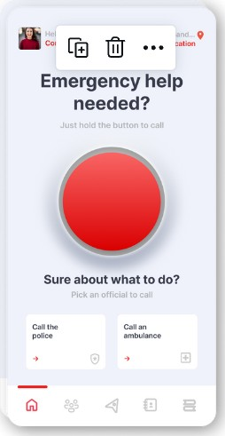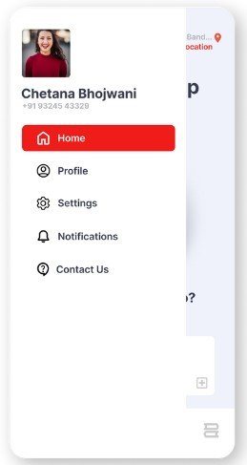

Image 4.1 The Emergency Button

#### Real Time Location Tracking

Continuously tracks the user’s location in real time, sharing it with designated contacts insuring quick response during emergencies.

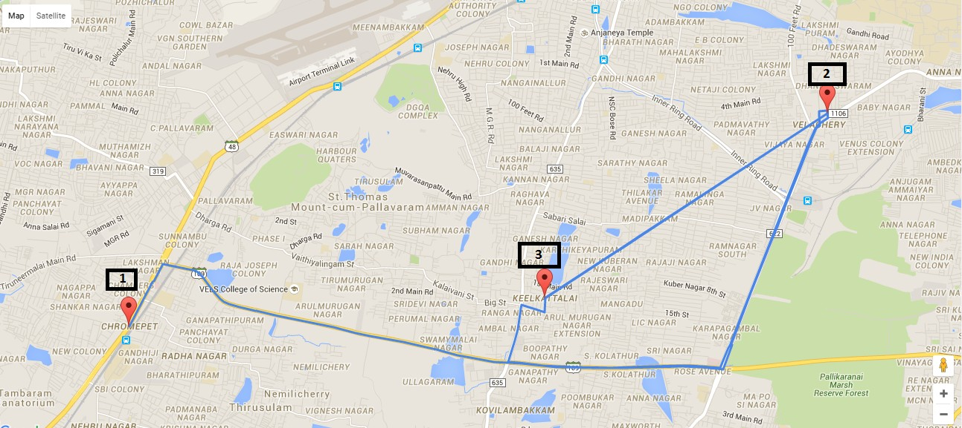

Image 4.2 Location Tracking

#### Audio and Video Recording

Allows discrete recording of audio and video during unsafe situations providing evidence that can be shared with concerned authorities.

#### One Handed Use

The apps interface will be designed in such a way that will be easy for one handed operation insuring quick access to emergency features without fumbling.

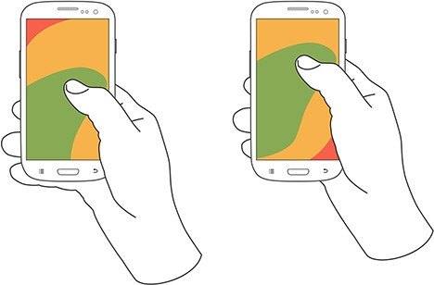

Image 4.3 One handed operation

#### Safety Word

In situations where you cannot access your device you can shout a preset safety world of your choice which would trigger emergency leading all necessary protocol to follow.

#### Notifications and Alerts

The app can provide notifications and alerts about local safety concerns recent incidence and safety tips.

#### False Shutdown

Suppose a miscreant has snatched your device and try to switch it off but if the false shutdown feature would be active then a black solid screen would appear which would look like the phone has been switched off but instead it would trigger emergency and also start recording audio and video.

#### Smartwatch Exclusive Feature

Smart watches have an accelerometer and a heart rate monitoring system. So, assume if your heart rate pikes to high and also your accelerometer shows that you are moving at a high speed then that would trigger emergency. Reason being if you are moving at fast pace and your heart rate spikes irrationally high it means that you are in danger otherwise in case you workout in the gym your heart beat would be high but you won't be changing locations does not triggering emergency also if you are in a known vehicle and the accelerometer notices high speeds but your heartbeat would not be too high since your body does not sense danger. Thus, this smartwatch exclusive feature can trigger emergency only once it has trapped both speed / location and heart rate.

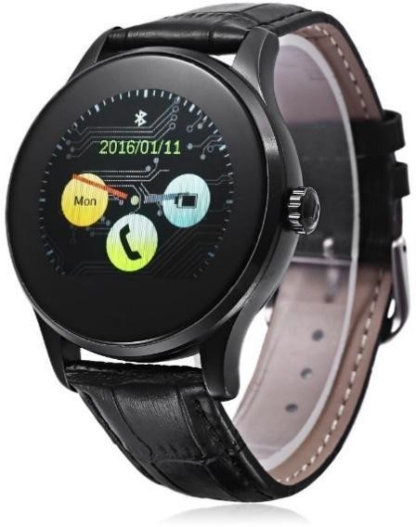

Image 4.4 Smart Watch

### Emergency Response Mechanism

The emergency response mechanism in the context of women safety app refers to the structured and rapid process that is triggered when a user activates an emergency alert or the distress signal within the app. This mechanism ensures that the user receives Swift and appropriate assistance from designated contacts and if necessary, then emergency services too. The basic flow when an emergency gets triggered is an alert going to the police and the medical authorities also the saved contact numbers along with the live location of the distress call. Reacting to which the respective authority can act accordingly.

### Data Security and Privacy

Data security and privacy are the paramount when implementing of women safety application and to protect the individual’s personal information and comply with the relevant regulations. Here are the key considerations and best practices for ensuring data security and privacy.

#### Data Minimisation

Collect and store only the minimum necessary data for the purpose of safety protocols needed. Avoid collecting unnecessary and additional personal data which is not required.

#### Data Backups

Regularly backup data and shorter reliable disaster recovery plan in case of data loss.

#### End to End Encryption

Implement end to end encryption for all communications within the app. This ensure that messages location data and other sensitive data information are only accessible to the sender and intended recipient.

#### User Consent

Clearly explain to the users what data will be collected and how it will be used. Obtain explicit consent from the users before collecting any personal information.

#### Anonymisation

Consider anonymising or pseudonimising user data to protect individual identities. This can be especially important for community features where in users interact with each other.

#### User Control

Provide user with the ability to control the data. Allow them to delete their accounts and associated data if they choose to do so.

#### Secure Authentication

Implement secure user authentication method such as multi factor authentication to prevent unauthorised access to user accounts.

#### Regular Security Audits

Conduct regular security audits and vulnerability assessments of the app to identify and address the potential security risks.

#### Data Access Controls

Limit access to user data to authorised personal only implement roll-based access control (RBAC) to restrict access based on job roles.

#### Compliance with Regulations

Adhering to relevant data protection regulations such as GDPR are HIPAA or local data protection loss depending on our apps scope and user base.

#### Data Breach Response Plan

Develop a data breach response plan outlining the steps to take in the event of a security breach. Promptly notify affected users if a breach occurs.

#### Regular Updates

Keep the app and its components up to date with security patches and updates to protect against known vulnerabilities.

#### Third Party Services

If the app is integrating third party services, then we need to ensure that these services follow a robust security and privacy practices.

#### User Education

Provide users with educational materials on how to use the app safely and protect their personal information.

#### Privacy Policy

Drafting of clear and comprehensive policy that outlines how data is collected used and protected. Making this policy easily accessible to users.

#### Ethical Considerations

Being mindful of ethical considerations when handling user data and prioritizing safety and well-being of the users above all else.

### IMPLEMENTATION

#### Define the Purpose and Objectives:

Clearly define the purpose of your app, which could include providing tools and resources for women's safety, emergency assistance, and empowerment.

#### Market Research:

Research your target audience to understand their specific needs, concerns, and preferences.

#### Design User-Friendly Interface:

Create an intuitive and user-friendly design to ensure easy navigation and quick access to essential features.

#### Features and Functionalities:

Determine the core features and functionalities of your app. Some common features include: Emergency SOS button

Real-time location sharing Safe routes and navigation Safety tips and resources

Contact lists for trusted contacts Incident reporting

Self-defence tutorials

#### Location Services:

Implement geolocation services to provide real-time tracking and location-based features.

#### SOS Functionality:

Implement an emergency SOS button that, when pressed, sends alerts to predefined contacts or emergency services with the user's location.

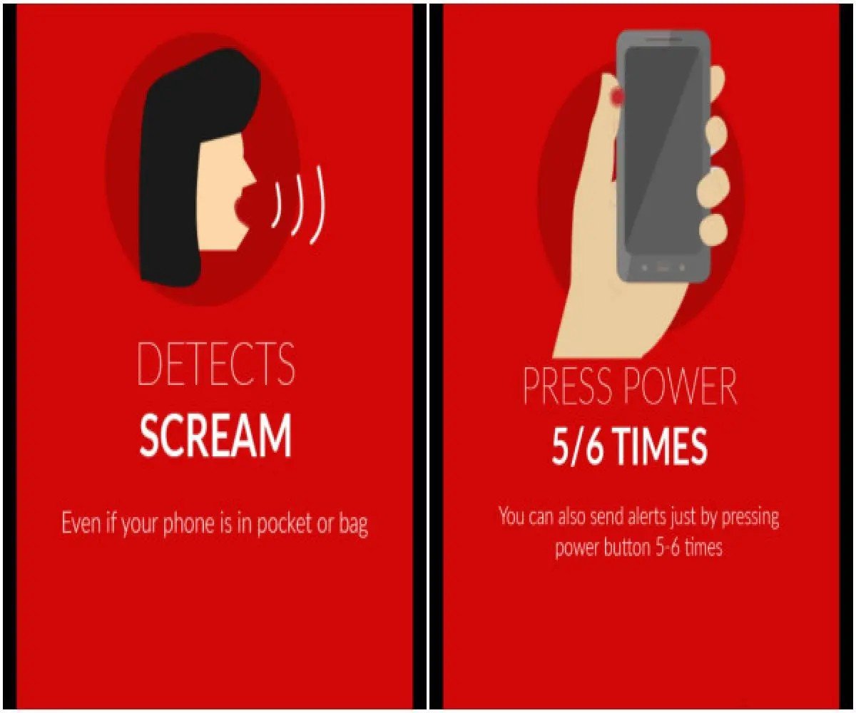

Image 5.1 Features

#### Real-time Location Sharing:

Enable users to share their real-time location with trusted contacts for added safety.

#### Safe Routes and Navigation:

Integrate a feature that suggests safe routes and provides navigation options based on user location and time.

#### Safety Tips and Resources:

Include a section with safety tips, information, and resources on self-defence, legal rights, and support services.

#### Contact Lists:

Allow users to create and manage lists of trusted contacts whom they can quickly reach out to in case of an emergency.

#### Incident Reporting:

Implement a feature that allows users to report incidents, which can be shared with authorities or relevant organizations.

#### Self-Defence Tutorials:

Offer tutorials or guides on self-defence techniques and strategies.

#### Privacy and Security:

Prioritize user data privacy and security by implementing robust encryption and ensuring that personal information is not easily accessible.

#### Testing and Quality Assurance:

Thoroughly test the app to identify and fix any bugs or usability issues.

### ADVANTAGES AND LIMITATIONS

* 1. **Advantages**

#### Emergency Assistance

Women's safety apps typically include an SOS feature that allows users to send distress signals to predefined contacts or emergency services with their location. This rapid response can be a lifesaver in critical situations**.**

#### Real-Time Location Sharing

Users can share their real-time location with trusted contacts, allowing friends and family to track their whereabouts and ensure their safety.

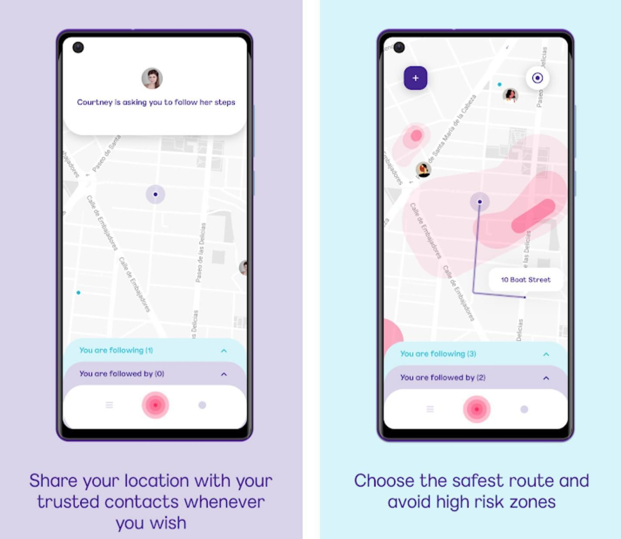

Image 6.1 Safe Zones

#### Safe Routes and Navigation

Some apps provide information on safe routes and navigation, helping women avoid potentially dangerous areas, especially when traveling alone at night.

#### Safety Tips and Resources

Women's safety apps often offer tips and resources on self-defence, legal rights, and support services, empowering users with knowledge and information.

#### Incident Reporting

Users can report incidents, harassment, or crimes through the app, which can be shared with law enforcement or relevant organizations for investigation and action.

#### Trusted Contacts

Users can create and manage lists of trusted contacts within the app, making it easy to reach out for help or support in emergencies.

#### Self-Defence Tutorials

Some apps include tutorials or guides on self-defence techniques and strategies, empowering women to protect themselves.

#### Privacy and Security

Many women's safety apps prioritize user data privacy and security, ensuring that personal information is kept safe and confidential.

#### Community and Support

Some apps build a supportive community of users who can share their experiences, tips, and advice, fostering a sense of solidarity among women.

#### Education and Awareness

Women's safety apps often raise awareness about women's safety issues, contributing to a more informed and vigilant society.

#### Deterrent Effect

Knowing that they have access to a safety app can act as a deterrent to potential attackers, as they know their actions may be reported.

#### Customization

Users can tailor the app to their specific needs and preferences, such as setting their emergency contacts and configuring notification settings.

#### Cross-Platform Accessibility

Many women's safety apps are available on both iOS and Android devices, making them accessible to a wide range of users.

#### Inclusivity

Some apps are designed to be inclusive and cater to diverse user needs, including those with disabilities or language barriers.

#### Continuous Improvement

Developers often update these apps regularly based on user feedback, adding new features and improving existing ones to enhance user safety.

#### Legal Compliance

Women's safety apps typically adhere to relevant data protection and privacy laws, ensuring that user data is handled responsibly.

#### Peace of Mind

These apps provide women with a sense of security and peace of mind, knowing that they have a tool to assist them in case of an emergency.

### Limitations

#### Dependency on Technology

Women's safety apps rely on smartphones and network connectivity. In areas with poor network coverage or when a smartphone is unavailable or out of battery, these apps may not be effective.

#### False Alarms

Users may accidentally trigger emergency alerts, leading to unnecessary panic or diverting resources from genuine emergencies.

#### Limited Reach

The effectiveness of these apps depends on the availability and willingness of emergency services to respond quickly. In some regions, emergency response may be slow or unreliable.

#### Privacy Concerns

Users may have concerns about the collection and storage of their personal data. Ensuring robust data privacy and security measures is essential.

#### User Engagement

Some users may install women's safety apps but forget to use or update them regularly. Ensuring user engagement and retention is a challenge.

#### Accessibility

Not all potential users have access to smartphones or the technical skills required to use these apps effectively. This can exclude certain segments of the population.

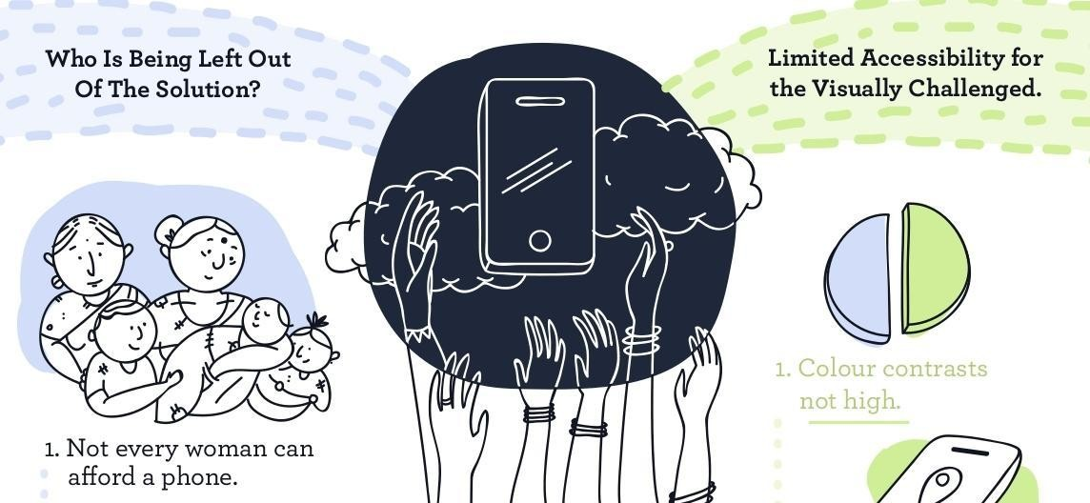

Image 6.2 Accessibility

#### False Sense of Security

Relying solely on a safety app may give users a false sense of security, leading them to take risks they otherwise wouldn't. Education on personal safety remains crucial.

#### Location Accuracy

The accuracy of GPS and location services can vary, affecting the precision of location sharing and safe route recommendations.

#### Cultural and Language Barriers

Women from diverse backgrounds may face language and cultural barriers when using these apps, hindering their effectiveness.

#### Network Vulnerabilities

The app's functionality may be compromised if hackers gain access to the user's device or the app's servers.

#### Device Compatibility

Women's safety apps may not work on all types of smartphones or may have limited compatibility with older devices.

#### Resource Constraints

Developing, maintaining, and updating these apps can be resource-intensive. Smaller organizations or individuals may struggle to provide ongoing support and improvements.

#### Reporting Challenges

Incidents reported through the app may not always lead to timely action, and there may be limitations in coordinating with law enforcement agencies.

#### Legal and Regulatory Challenges

Compliance with data protection and privacy laws can be complex and may vary by jurisdiction, adding legal challenges to app development.

#### User Behaviour

The app cannot control user behaviour, and individuals may still engage in risky activities or put themselves in dangerous situations.

#### Prevention vs. Reaction

Most women's safety apps focus on reacting to emergencies rather than preventing them. A comprehensive approach to safety should include both aspects.

### CONCLUSION

In this study, we have successfully designed and implemented the Kavach women's safety app, featuring a location tracking subsystem that utilizes GPS technology to monitor users' whereabouts, ensuring their safety when working late or moving through different locations. This app not only provides a secure environment for women but also serves as a powerful deterrent to potential criminals, contributing to a decrease in crime rates against women. It is currently compatible with Android smartphones, but future development aims to make it available on wearable devices as well. The Kavach app encompasses a range of essential features, including live location tracking, SOS alerting, a siren, voice recording, and a dedicated helpline, offering women confidence and security in their daily lives. Moving forward, it is crucial to invest in its ongoing development, gather user feedback, and collaborate with law enforcement agencies to maximize its impact. Tailoring the app to meet the specific safety needs of various regions within India will further enhance its effectiveness. Kavach represents not only a technological innovation but also a beacon of hope and empowerment for women across the country, symbolizing our commitment to creating a safer environment for women and fostering a culture of safety in India. Together, we can work towards a brighter, safer future for all.

# LIST OF REFERENCES

1. Ravi Sekhar Yarrabothula Bramarambika Thota, "ABHAYA: AN ANDROID APP FOR THE SAFETY OF WOMEN," IEEE, 1 December 2015.
2. Alisha Maruti Gawade, Amruta Jadhav, and Sachin Shankar Kumbhar, "S-ZONE: A SYSTEM FOR WOMEN SAFETY & SECURITY SYSTEM," Journal of Information, Knowledge And Research In Electronics And Communication Engineering, ISSN: 0975 – 6779, Volume 04, Issue 02, Nov 16 To Oct 17.
3. Sagar Khan, Harish Shinde, Ankita Zaroo, Rashmi Koushik, F. S. Ghodichor, "SHIELD: Personal Safety Application," IRJET Volume 04 Issue 05, May 2017.
4. Piyush Bhanushali, Rahul Mange, Dama Paras, Prof. Chitra Bhole, "Women Safety Android App," IRJET Journal, Volume 5, Issue 4, April 04, 2018.
5. N. Ramesh Kannan, S. Sujitha, S. Ganapathy Subramanian, "Women Safety Mobile App," International Journal on Cybernetics & Informatics (IJCI), Vol. 10, No. 1/2, May 2021.
6. D. S. Prashanth, G. Patel, and B. Bharathi, "Research and development of a mobile-based women safety application with real-time database and data-stream network," 2017 International Conference on Circuit, Power and Computing Technologies (ICCPCT), 2017.
7. "Raksha - women safety alert," Bharatsweva.com. [Online]. Available: https://play.google.com/store/apps/details?id=com.portalperfect.sosapp&hl=en. [Accessed August 25, 2019].
8. "I go safely app." [Online]. Available: [http://www.igosafely.com/.](http://www.igosafely.com/) [Accessed August 25, 2019].
9. "Shake to Alert." [Online]. Available: [https://www.shake2alert.co.za/.](http://www.shake2alert.co.za/) [Accessed August 25, 2019].
10. "Women safety applications." [Online]. Available: enggjournal.com. [Accessed August 30, 2019].
11. Ravi Sekhar Yarrabothu and Brama Ambika Thota, "ABHAYA: An Android App for the Safety of Women," IEEE INDICON 2015 Journal Publication.
12. Nirbhaya: Be Fearless. [http://www.nirbhaya.mobi.](http://www.nirbhaya.mobi/) Accessed June 1, 2015. International Labour Organization, 2012, "ILO Global Estimate of Forced Labour: Results and Methodology," p. 14, Geneva.
13. M. Mahajan, K. Reddy, and M. Rajput, "Design and implementation of a rescue system for safety of women," 2016 International Conference on Wireless Communications, Signal Processing and Networking (WiSPNET), 2016.
14. Anmol Agarwal, Nitish Kumar Sharma, Piyush Gupta, Prakhar Saxena, Rohit Kumar Pal, Siddharth Mehrotra, Prof. Prabha Nair, vol. 2, issue 5, May 2014, pp. 20-25.
15. Albert Mayan.J, Julian Menezes. R and Breezely George M, "Designing a Customized Testing Tool for Windows Phones Utilizing Background Agents," International Conference on Soft Computing Systems (ICSCS) 2015.
16. Dhruv Chand, Sunil Nayak, "A Mobile Application for Women’s Safety: WoSApp," IEEE TENCON 2015 Journal Publication.

**BIBLIOGRAPHY**

29

1. Smith, J. (2020, July 15). Women's Safety Apps: A Comprehensive Review.
2. Johnson, A., & Williams, M. (2019). Assessing the Effectiveness of Women's Safety Apps. Journal of Mobile Technology in Medicine, 8(2), 45-52.
3. Brown, L. (2018). Mobile Apps for Personal Safety: A User-Centric Study. International Journal of Human-Computer Interaction, 34(9), 821-835.
4. Women's Safety Foundation. (2021). Top 10 Women's Safety Apps You Should Know About.
5. Thomas, C., & Anderson, S. (2017). Evaluating the Impact of Women's Safety Apps on Campus: A Case Study. Journal of Campus Safety, 12(3), 18-26.
6. National Institute of Justice. (2016). Mobile Applications for Public Safety: A NIJ White Paper.
7. Garcia, R., & Martinez, E. (2019). The Role of Women's Safety Apps in Preventing Gender-Based Violence: A Review of the Literature. Gender and Technology Journal, 21(4), 321-337.
8. SafeHer, Inc. (2020). SafeHer: Redefining Women's Safety.
9. Amnesty International. (2018). No More Stolen Sisters: The Need for a Comprehensive Response to Discrimination and Violence Against Indigenous Women in Canada.
10. UN Women. (2019). Safety Apps for Women: A Global Review.

**Web links:**

1. https://[www.safetytechblog.com/womens-safety-apps-review](http://www.safetytechblog.com/womens-safety-apps-review) 2. https://doi.org/10.21037/jmtm.2019.04.05

3. https://doi.org/10.1080/10447318.2017.1411217

1. https://[www.womenssafetyfoundation.org/stay-safe/top-10-apps](http://www.womenssafetyfoundation.org/stay-safe/top-10-apps)
2. https://[www.journalofcampussafety.com/article/evaluating-the-impact-of-womens-safety-](http://www.journalofcampussafety.com/article/evaluating-the-impact-of-womens-safety-) apps-on-campus-a-case-study
3. https://nij.ojp.gov/library/publications/mobile-applications-public-safety-nij-white-paper 7. https://doi.org/10.1080/15205436.2019.1674402
4. https://[www.safeher.com/about](http://www.safeher.com/about)
5. https://[www.amnesty.ca/sites/amnesty/files/amr200032018en_no_more_stolen_sisters_-](http://www.amnesty.ca/sites/amnesty/files/amr200032018en_no_more_stolen_sisters_-)

_the_need_for_a_comprehensive_response_to_discrimination_and_violence_against_indigen ous_women_in_canada.pdf

1. https://[www.unwomen.org/media/headquarters/attachments/sections/library/publications/201](http://www.unwomen.org/media/headquarters/attachments/sections/library/publications/201) 9/safety-apps-for-women-a-global-review-en.pdf?la=en&vs=5391

# GLOSSARY

**Algorithm** An algorithm is a step-by-step procedure or set of rules for solving a specific problem or accomplishing a specific task. Algorithms are used extensively in coding for various purposes, such as data processing and analysis.

**API** An API is a set of rules and protocols that allows different software applications to communicate with each other. In the context of a women's safety app, APIs may be used to integrate external services or data sources, such as mapping services or emergency contact databases.

**Authentication** Authentication is the process of verifying the identity of a

user. In coding, this involves implementing secure login methods to ensure that only authorized users have access to the app's features and data.

**Backend** The backend of a mobile app refers to the server-side components and logic that handle data storage, processing, and communication with the app's front-end. It includes databases, web servers, and application servers.

**Battery Optimization** Battery optimization features in the app aim to minimize

power consumption while ensuring that essential safety functions remain operational. This is crucial for maintaining the app's effectiveness over extended periods.

**Database** A database is a structured collection of data that can be accessed, managed, and manipulated. In women's safety apps, databases are used to store user profiles, emergency contact information, and incident logs.

**Emergency Contact** An emergency contact is a person or entity designated by

the user within the women's safety app to be notified in case of an emergency. This contact is typically reached out to automatically when the user activates a distress signal or alert.

**Emergency Services** Some women's safety apps have the capability to directly

connect with emergency services such as the police,

paramedics, or fire department in case of a serious emergency, streamlining the response process.

**Encryption** Encryption is the process of converting data into a secure format to prevent unauthorized access. In women's safety apps, encryption is crucial for protecting user data and communications.

**Error Handling** Error handling in coding involves managing and responding

to unexpected issues or errors that may occur during the execution of the app. Proper error handling ensures that the app remains stable and user-friendly.

**Frontend** The frontend of a mobile app refers to the user interface and user experience components that users interact with directly. This includes screens, buttons, forms, and other visual elements.

**Geofencing** Geofencing is a technology used in women's safety apps to create virtual boundaries around specific geographic areas. When the user enters or exits these predefined zones, the app can trigger notifications or alerts, enhancing safety measures.

**Geolocation Services** Geolocation services provide access to a device's GPS or

other location-sensing capabilities. In coding, APIs like the HTML5 Geolocation API are used to obtain the user's current location for real-time tracking in women's safety apps.

**GitHub** GitHub is a web-based platform for hosting and managing Git repositories. It is commonly used for version control and collaborative coding in software development projects, including women's safety apps.

**GPS** GPS is a satellite-based navigation system that provides location and time information in all weather conditions. Women's safety apps often use GPS to pinpoint the user's precise location in real-time, which can be crucial for assistance and safety services.

**Incident History** Incident history refers to a log or record within the app that

documents past safety-related events or alerts triggered by the user. This history can be valuable for review, analysis, and reporting purposes.

**Panic Button** A panic button is a feature within the women's safety app that allows the user to send an immediate distress signal or alert. This is typically used in emergency situations to notify predefined contacts or emergency services.

**Push Notification** Push notifications are messages sent from a server to a user's

device through the app. They can be used to alert users to important information or events, such as safety alerts or updates.

**Real-time Tracking** Real-time tracking is the continuous monitoring of a user's

location as they move. Women's safety apps often use this feature to allow friends, family, or authorities to track the user's location in real-time for safety purposes.

**REST API** A REST API is a type of web service that adheres to the principles of Representational State Transfer (REST). It is commonly used to enable communication between the app's frontend and backend, allowing data retrieval and manipulation.

**Safety Network** A safety network is a group of trusted contacts within the

app that the user can reach out to for assistance or support. These contacts may include friends, family members, or local authorities.

**Safety Tips** Safety tips are educational resources or recommendations provided within the app to help users stay safe in various situations. These tips can cover a wide range of topics, including personal safety, self-defense, and emergency preparedness.

**SDK** An SDK is a set of tools, libraries, and documentation that developers use to build applications for specific platforms or frameworks. For mobile app development, SDKs like React Native provide the necessary resources to create cross-platform apps efficiently.

**SOS Code** An SOS code is a specific sequence of actions or inputs, often a button press or gesture, used to discreetly send an emergency alert. This code is designed to quickly and quietly seek help when the user is in distress.

**Safe Zones** Safe zones are predefined geographical areas set by the user within the app. These areas are considered safe, and the app may not trigger alerts or notifications while the user is within them. It's a feature that enhances user control and convenience.

**Version Control** Version control systems, such as Git, are used by developers

to track changes to the app's source code. This allows for collaboration among developers and ensures that code changes can be managed and rolled back if necessary.

**Voice Activation** Voice activation is a feature that allows users to trigger

certain functions of the app using voice commands. It can be especially useful in situations where manual interaction with the app may not be possible, such as during an emergency.

**Geomagnetic Senso**r Earth's magnetic field is also known as the geomagnetic

field. Geomagnetic sensors are sensors that detect the magnetic field of the Earth and are commonly referred to as electronic compasses. Geomagnetic sensors can determine direction by detecting the geomagnetic field.